STORY
Story Description
Story Point 1 — Introduction to Economic Freedom
Provides a general overview of economic freedom scores across countries using ranking charts.
Purpose:
To introduce users to global variations in economic freedom.
Insight:
Some countries consistently show high institutional strength, while others show weak economic structures.

Story Point 2 — Economic Freedom and Income
Uses a scatter plot comparing Economic Freedom Score with GDP per capita.
Purpose:
To examine whether freedom relates to prosperity.
Insight:
Countries with higher economic freedom generally have higher income levels.

Story Point 3 — Regional Comparison
Uses a world map visualization showing geographic distribution.
Purpose:
To identify regional development differences.
Insight:
North America and Western Europe show higher economic freedom, while several developing regions show lower scores.

Story Point 4 — Institutional Indicators
Compares specific indicators such as:
• Property Rights
• Trade Freedom
• Investment Freedom
• Tax Burden
Purpose:
To identify which policies influence economic performance.
Insight:
Institutional quality (legal protection and open markets) is more closely associated with prosperity than taxation alone.

Story Point 5 — Employment and Stability
Compares economic freedom with unemployment and inflation.
Purpose:
To evaluate macroeconomic stability.
Insight:
Countries with higher economic freedom often show lower unemployment and more stable economic conditions.

Story Point 6 — Conclusion
Summarizes the overall findings.
Final Findings:
• Economic freedom is positively associated with income levels
• Strong institutions support economic development
• Regional economic differences are significant
• Data visualization improves economic understanding

Story Outcome
The Tableau Story provides a structured explanation of economic relationships and allows users to follow the analysis logically. It transforms complex global economic data into a clear narrative that supports academic discussion and interpretation.

Reference Images

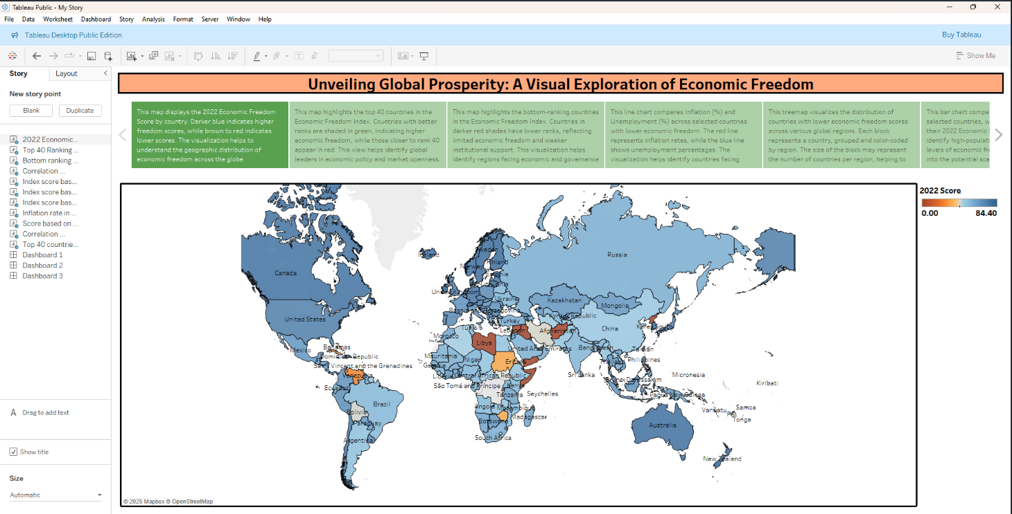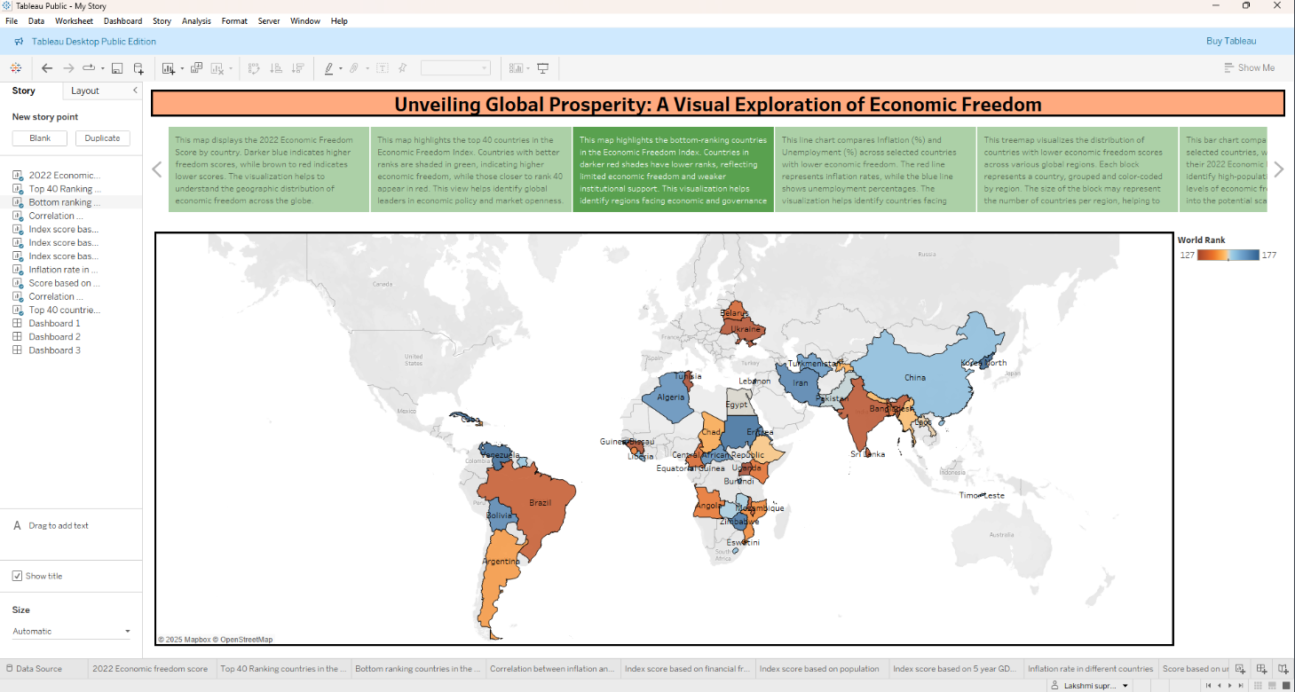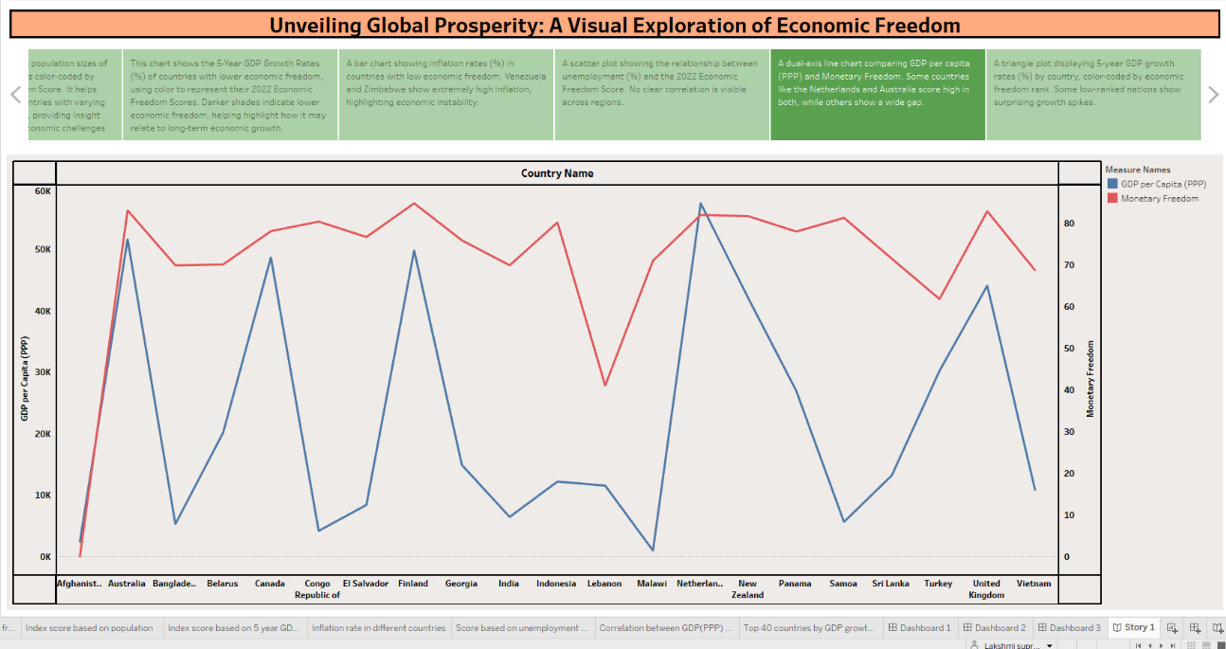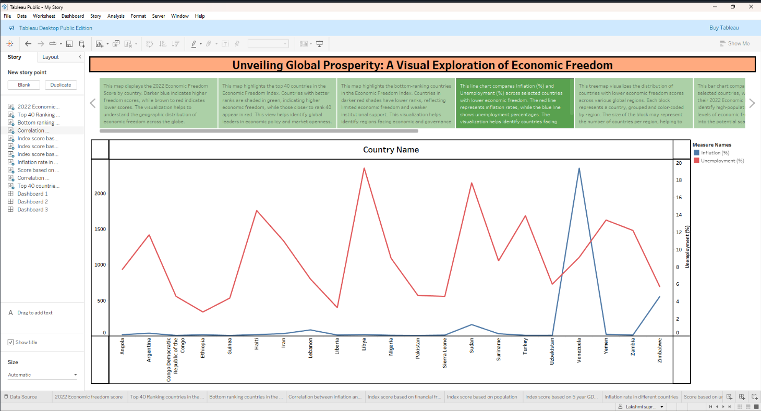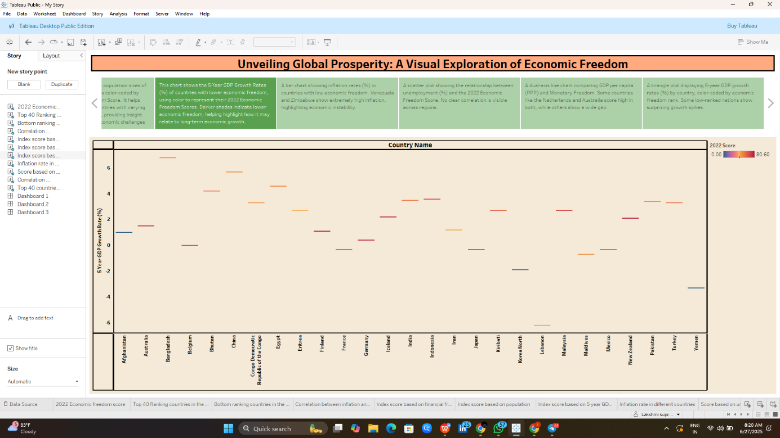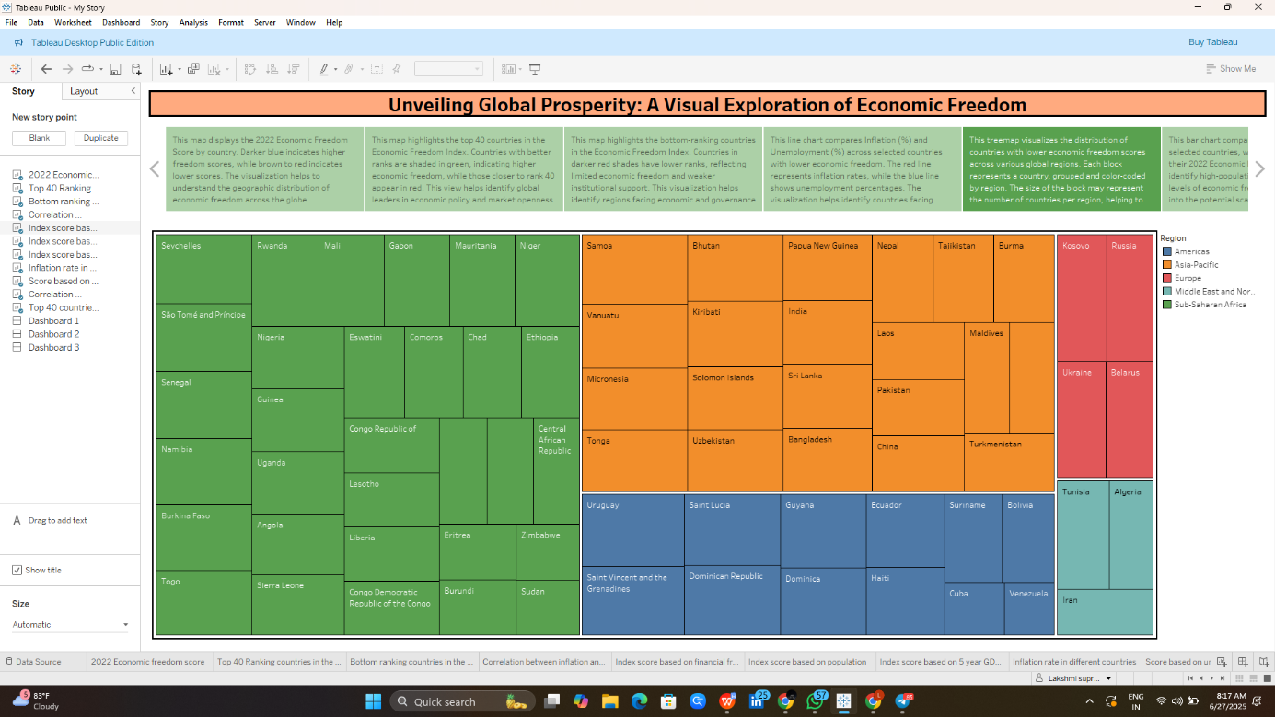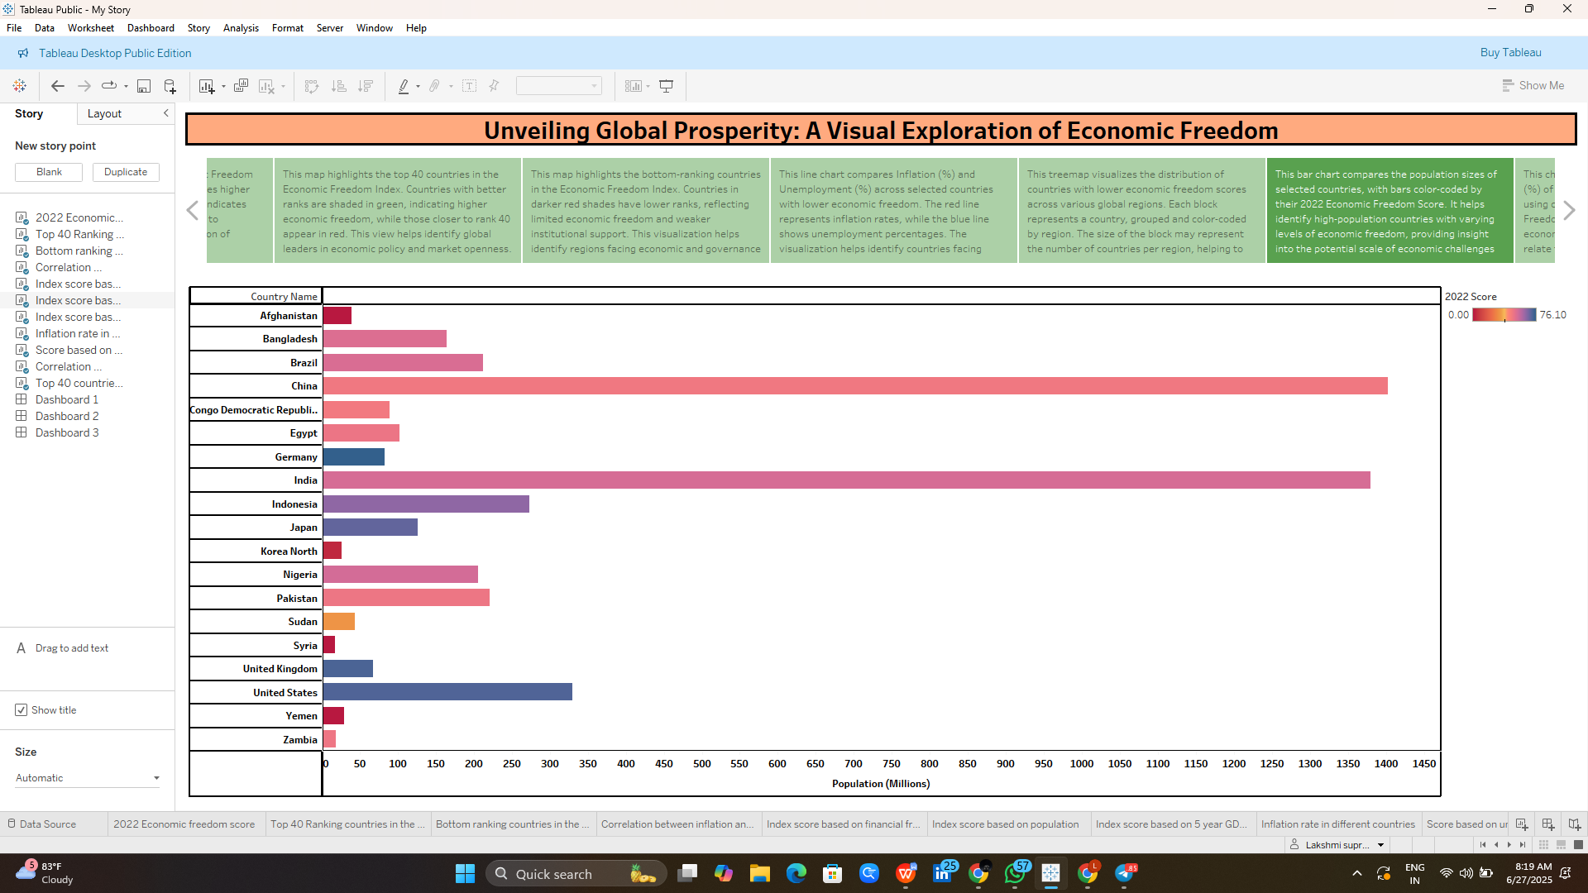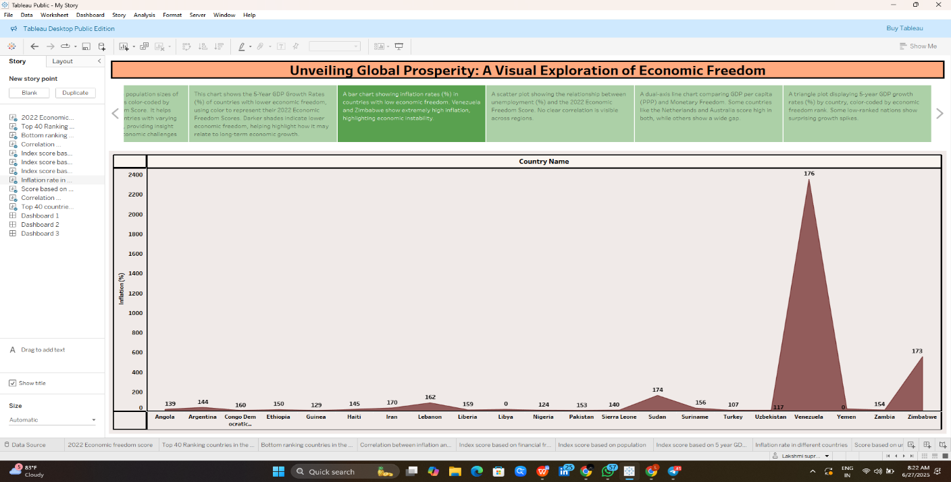

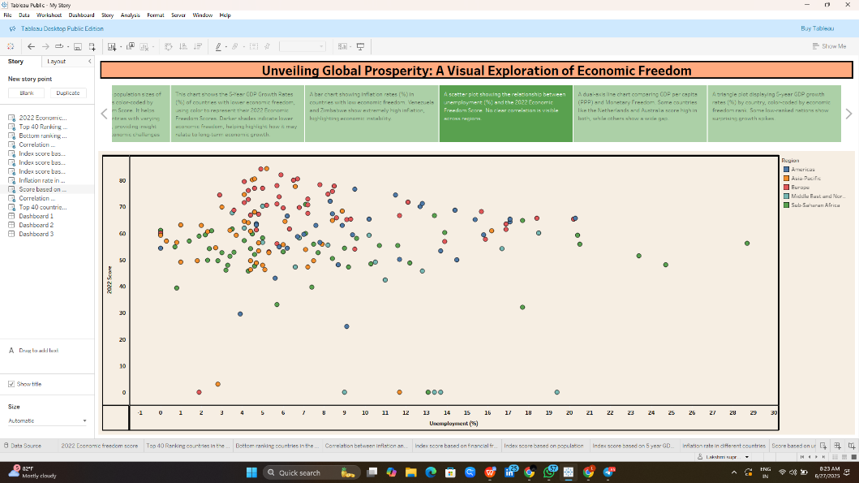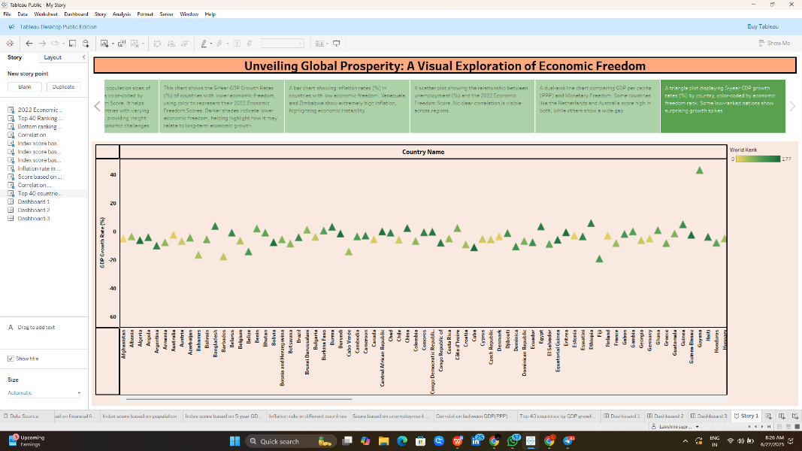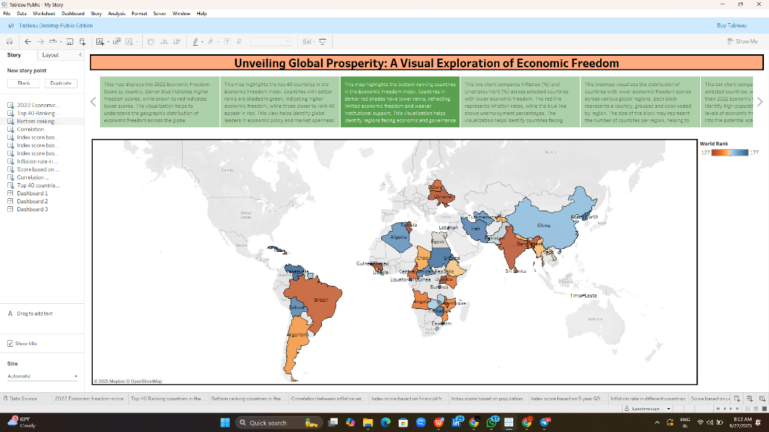

Reference link:
https://public.tableau.com/app/profile/lakshmi.supriya.jonnalagadda/viz/MyStory_17509593255230/Story1

